ASSIGNMENT 2

HARSHITAA ASHISH – 21BCY10123 – [harshitaa.ashish2021@vitbhopal.ac.in](mailto:harshitaa.ashish2021@vitbhopal.ac.in)

1. NMAP

Scan website using Nmap

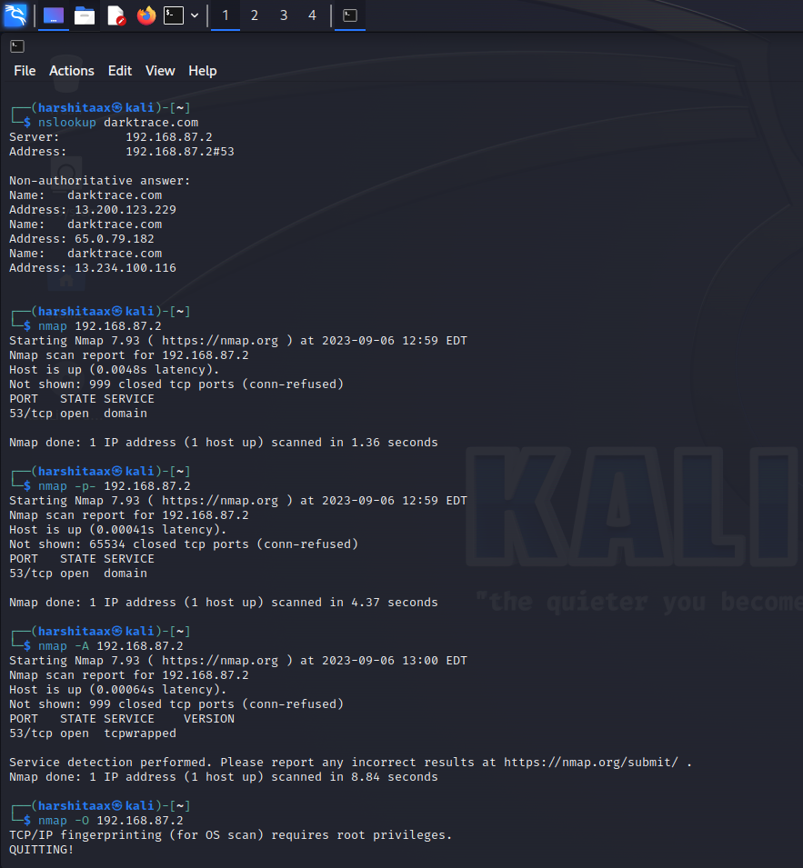

1. Metasploit

